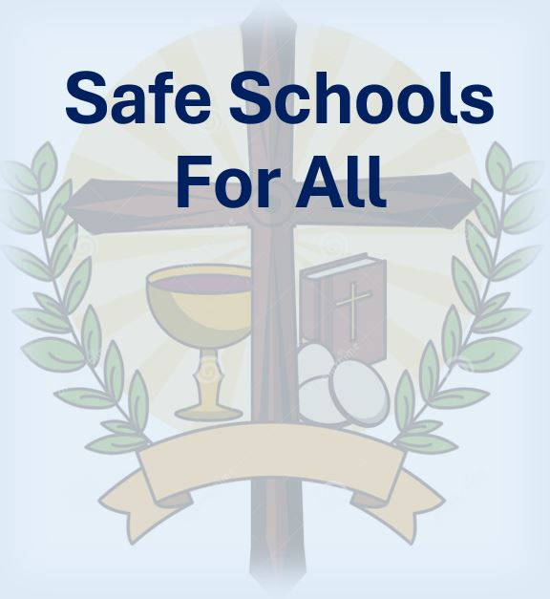

**St. Leo School**

**Safe and Accepting Schools Plan**

**2024-2026**

***A positive school climate and a safe learning and teaching environment are essential for students to succeed in school. This means that everyone feels they are safe, welcome, and respected.***

***“Pilgrims of Hope”***

**2024-2026**

|  |  |  |
| --- | --- | --- |
| **PRIORITY: BELONGING** | | |
| **Goals** | **Key Activities** | **Indicators of Progress** |
| Members of our Catholic Learning Communities will live out Gospel Values and Catholic Social Teachings to foster a broader sense of peaceful, safe, and accepting school cultures by facilitating greater participation in Mass, sacramental participation, and community outreach as a calling. | Schools will articulate clear expectations for the community by annually reviewing the BHNCDSB District Code of Conduct and related safe and inclusive schools’ policies and procedures.  School Safe and Accepting School Plans will be reviewed and revised annually at each school (reflecting the District Safe and Accepting Schools Plan). | Staff, parents, and students will be knowledgeable about and respect/adhere to the Code of Conduct, as well as explicit behavioural expectations, in addition to safety, and equity policies. Administration and Staff will see greater awareness of, and appropriate participation in Masses. Participation in various classroom planned community outreach projects (e.g., Food Drives, Tree of Warmth, Faith Ambassadors) will be evident. |
| **PRIORITY: TEACHING AND LEARNING** | | |
| **Goals** | **Key Activities** | **Indicators of Progress** |
| Promote and provide resources/materials and opportunities necessary to be sure ALL students feel welcome, accepted, and experience a sense of belonging, with the opportunity to contribute to the school community. | Culturally responsive resources/activities will be shared with Staff to promote safe and caring classrooms and align with the Board’s Religious Education and Family Life Program, Ontario Catholic School Graduate Expectations and the Board’s Equity and Inclusive Education Policy. Administration will continue to promote and provide resources for use in classrooms to promote safe, inclusive, and caring learning environments with positive, Growth Mindset attitudes (i.e., Indigenous Education resources, Supporting Minds document, Math Up, Special Education resources, Self Reg, Trauma informed etc.). Teachers will be encouraged to utilize the Faith and Wellness resource housed within the School Mental Health Action Kit MH LIT: Student Mental Health in Action - School Mental Health Ontario (smho-smso.ca) Admin and Staff will provide opportunities for our Youth Faith Ambassadors Leadership team to bring community building activities to life in various student planned activities. | Administration will monitor current resources and ensure appropriate evidence-based resources are available to staff. Evidence of the Faith and Wellness resource as well as the Board’s Self-Reg/trauma-informed/ mental health practices and Growth Mindset approaches in everyday classroom practices. Students will demonstrate enhanced knowledge about mental health, self-awareness, coping strategies, resilience and know how to access support for themselves and their peers. Representation and perspectives from equity seeking groups and Indigenous communities are included in educational planning for safe and accepting schools. |
| **PRIORITY: WELLNESS** | | |
| **Goals** | **Key Activities** | **Indicators of Progress** |
| Provide classroom support and training to address current and relevant safe school issues with the use of Board Support Staff (CYW and Social Worker) and Public Health Nurse to promote self-awareness about the need for and access to support. Admin and Staff Equity Leads will engage fellow staff members in reflection and unpacking of our own personal biases and to build awareness of how organizational practices can be part of systems of oppression and exclusion. Continue to provide support for educators on their Self-Reg© journey and the School Board Self-Reg© implementation plan. | Admin and Staff will review the School Emergency Response Resource Binder. Admin will update the Notification of Potential Risk of binder and share as appropriate with school staff. Staff will make use of in-school resources such as CYW, Social Worker, and Public Health Nurse to do whole-group classroom presentations and more specifically targeted work with small groups and individuals as needs dictate. Teachers will actively reflect on their own personal social identity to uncover the potential biases that may subconsciously skew their classroom practices when operationalized. Enhance educator understanding of the Board’s SelfReg© implementation Plan and encourage them to take advantage of MEHRIT Centre training opportunities/courses to build staff and student capacity in Self- and Co-Regulation. | Consistent approaches and practices will be in place across the district. Staff will know where to access the policies and procedures to respond effectively to unsafe situations. Staff and admin will see greater participation in activities aimed at inclusiveness, and less distress due to socio-emotional turmoil in classrooms as well as at recess. The Board’s Self-Reg/trauma-informed/ mental health awareness approaches will be evident in everyday classroom practices. Administrators, Educators, and Support Staff will have a better understanding of their role in assisting others by reframing others’ reactions as stress responses rather than misbehaviours and co-regulating by cueing safety as needed. Staff and students will have a better understanding of stressors that trigger their own personal stress responses, as well as ways to reduce them and restore their energy levels. |
|  |  |  |